WEEKEND WORKSHOP
WATERCOLOUR MIX & MATCH & PAINT
SATURDAY 21 & SUNDAY 22 March 2020
10am – 4pm

Explore the different characteristics of colours, and how to build up layers of paint to maintain transparency, yet achieve strong and vibrant colours and learn about glazing to create colour intensity. Using a limited range of 6 primary colours (warm and cool), create your own watercolour charts of 450 colours, enabling easy mixing and matching of almost any botanical colour. Learn about colour harmony and primary, secondary and complimentary colours. Make your colours sing! Class and individual demonstrations and tuition. All skill levels welcome. Preprinted colour charts available ($2.50 per sheet).

Throughout the workshop you will be painting various colour mixes then painting a subject from those mixes. Bring any flowers, leaves, seeds, pods, nuts or any other subjects. Bring more than one subject.

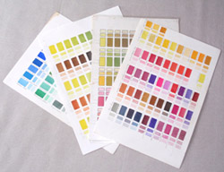

Saturday 21 and Sunday 22 March 2020
10am-4pm
Room 309

BOOKINGS BY PHONE OR ONLINE
WEA, 72 Bathurst Street Sydney NSW 2000
By phone: (02) 9264 2781
Website: www.weasydney.com.au

