Make your Colours Sing with the Birds and the Bees

PLANTS & POLLINATORS

15-19 April (inclusive) 2018

Open to the Intermediate to Advanced Artists only
BA/VisArt, BFA (Hons) Scientific Plant Illustration, Grad. Dip. VET (Adult Education), Cert IV (Workshop and workplace training)
This intensive workshop will challenge and reward you on many levels and will extend your overall knowledge of painting techniques while discovering the unique methods of adding pollinators to plants. Identify the correct pollinators which could be birds, bees or butterflies for your plant or flower subject. It is an exciting skill to learn how to place them to create the greatest impact, and it also gives further interest and information to the botanical subject. Bring your chosen plant and images you have for a pollinator subject.
You will discover the importance of the processes needed for outstanding botanical paintings. These will include strong tonal contrasts, how to paint realistic highlights and shadows and how to create a balanced composition and put depth in your work, dry brush painting, mixing, matching, layering, and glazing of transparent colours.
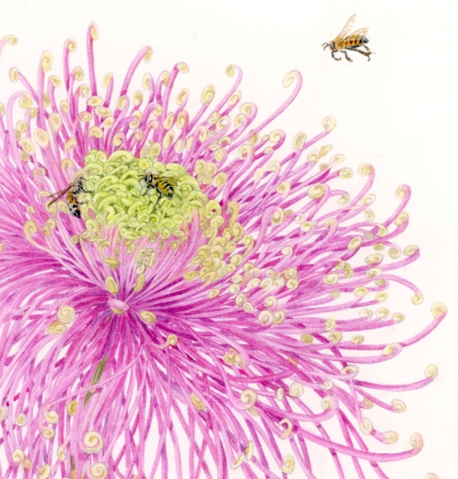
Make your colours sing! Over glazing will enhance the colours and give them life and vibrancy. Learn about colour harmony and how to create a three-dimensional illusion. Students will not only draw and paint but will learn how to observe and use their natural skills and artistic abilities to enhance any painting. An important aspect of this workshop is individual tuition and demonstrations as well as class demonstrations which are an integral part of this course. Leonie’s teaching methods have proven to be not only highly successful but also an enjoyable experience.
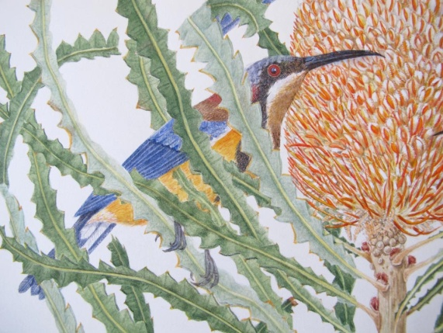

Fay Boyd’s Grafton Fine Visual Arts School
https://fayboydsfineartschool.com/

