WEEKEND WORKSHOP
18-19 November 2017

‘WATERCOLOUR MIX & MATCH TO MAKE ANY COLOUR’

Explore the different characteristics of colours, and how to build up layers of paint to maintain transparency, yet achieve strong and vibrant colours and learn about glazing to create colour intensity.

Using a limited range of 6 primary colours (warm and cool), create your own watercolour charts of 450 colours, enabling easy mixing and matching of almost any botanical colour. Learn about colour harmony and primary, secondary and complimentary colours. Make your colours sing!

On day 2 bring in some simple subjects such as leaves or a very simple flower and you will have the opportunity to use your new skills to paint these. Watercolour painting techniques will be demonstrated.

Class and individual demonstrations and tuition. All skill levels welcome. Preprinted colour charts available.

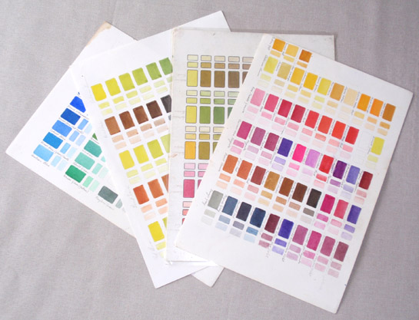

2 days 10am – 4pm Saturday 18 November & Sun 19 November 2017

